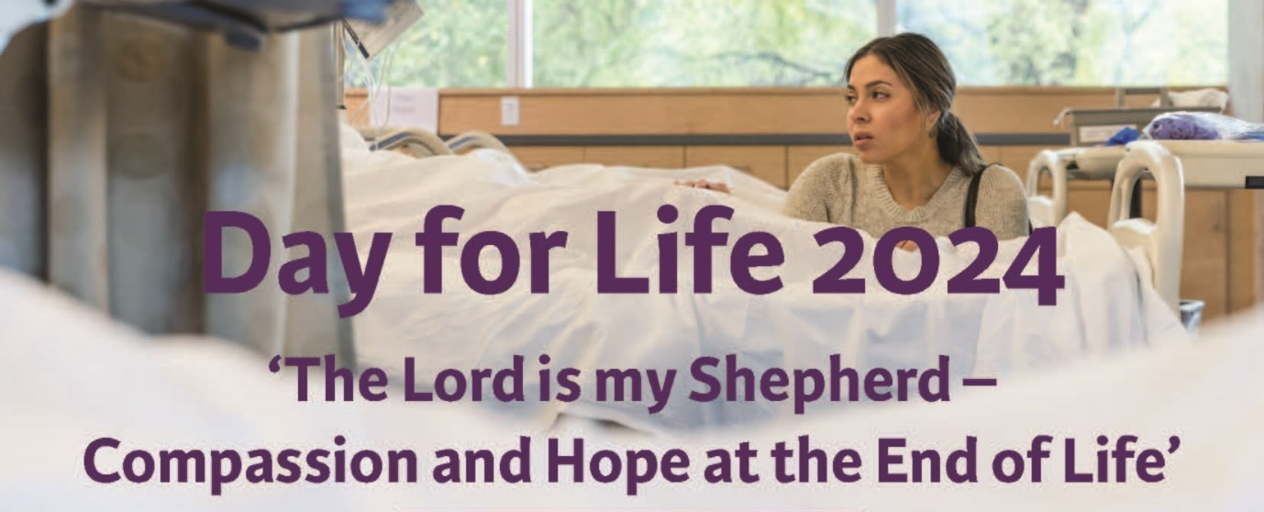
Day for Life – 16th June 2024
Suggestions for Homily
Note: The focus for this year’s Day for Life is on how we support people who are dying with our presence and our care. The homilist will want to reflect on how the Scripture readings speak to that challenge. He would do well to weave into that reflection something of his own personal experience of accompanying parishioners through the final weeks and days of life. This is not intended to be a ready-made homily.
- The experience of strength and fruitfulness. Between them, the first reading and the Gospel offer us three powerful images: (the tiny mustard seed which becomes a big shrub and provides shelter for the birds; the seed which – even in the night - produces grain and provides a plentiful harvest; and the tall imposing Cedar tree). Each of these, in its own way confidently reflects abundant life and health. This is not unlike the experience most of us have in the prime of life, when we are working hard, playing hard and building homes and families. We walk tall and we are confident.

- There is something of a mystery underlying all this growth and vibrancy. We are told that the farmer “knows not how” the seed brings forth the grain. Is there a suggestion in here that, as St. Paul writes elsewhere, “one sows, another waters, but it is God who gives the growth”? For most of us the mystery deepens when we begin to experience, in ourselves or in others, the first signs of physical weakness and loss of energy. Perhaps there is a diagnosis of chronic or even terminal illness. What has happened to the woman or the man who, previously was so full of life and energy? Disappointment, sadness, fear, and even anger can all be part of this.

- Doctors and nurses can achieve impressive results with the help of modern technology, but there comes a time when even they have to say that further treatment will not be of any use to the person who is sick. This news is difficult to communicate sensitively and even more difficult to receive. This is where family and friends often come into their own, with the continuing support of chaplains, nurses and doctors. The ending of treatment is not the ending of life; it is the beginning of another stage of life, when the sick person will be accompanied and cared for, physically, emotionally and spiritually. Pain relief is part of that, but there is so much more to palliative care. Often it is not so much what we do that makes the difference, but simply the fact that we are present, and that we are ready to listen.

- [At this point the homilist might consider whether he can, without naming names, tell a personal story from his own pastoral experience, of what it means to accompany somebody who is dying. Alternatively, he might make use of the story of Matt, which is included as part of the Message for the Day for Life.]

Among the lessons which might be drawn from this human experience are:

- something about the holistic care that is provided in Hospices or at home, and which gives people freedom to live as fully as possible.

- the fact that good quality end of life care very often allows people the space to talk to family and friends in a way they haven’t done before, to heal old hurts, to come to a deeper understanding of themselves, and a deeper awareness of the closeness of God who loves them.

- that, in the experience of terminal illness, a person may, without actively choosing to die, begin to have the inner freedom to let go, and to look to eternal life. (See second reading: “we are full of confidence … and actually want to be exiled from the body and make our home with the Lord”).

- that by contrast, assisted suicide or euthanasia, far from giving people autonomy, puts a definitive end to their freedom and, with it, any possibility of growth or healing.

- The homily might conclude by revisiting the image of the Cedar tree (first reading). What does it mean for us to say that God will take a shoot “from the highest branch” of the Cedar tree, and “plant it on the high mountain of Israel, (where) it will sprout branches and bear fruit”? Is it perhaps a way of saying that God, who seems to take the gift of life away from us, actually commits to giving it back to us again, only better than it was before. “I the Lord, am the one who stunts tall trees and makes the low ones grow, who withers green trees and makes the withered green”. God is the one in whom our deepest heart wishes are fulfilled.

Intercessions – Day for Life – June 16, 2024

Bishop/Priest/Deacon:
On this Day for Life, conscious in a particular way of the gift of human life which is entrusted to our care, we bring our prayers to God.
- We pray for Pope Francis, as he himself bears witness to hope in the frailty of his advanced years – that the Lord may strengthen him and give him courage to complete the mission for which he has been sent. Lord hear us.

- We pray for all who are faced with degenerative or terminal illness - that they may experience the healing presence of Christ in the care of those who accompany them day by day. Lord hear us.

- We pray for those who form public policy and who enact our laws – that in their efforts to serve the common good, they may always have in mind the inherent dignity of every human person, which is not the gift of society, but the gift of a loving creator. Lord hear us.

- We pray for healthcare professionals – that, even when a cure is no longer possible, they may continue to provide gentle and life-affirming care for all their patients. Lord hear us.

- We pray for an end to war - may respect and peace be always at the heart of human relationships. Lord hear us.

- We pray for our family members, friends and neighbours who have died - may they be surprised by joy as their best hopes are fulfilled in the Kingdom of heaven. Lord hear us.

Bishop/Priest/Deacon:
Lord “we proclaim your love in the morning and your truth in the watches of the night”. Be with us, as we accompany, in the morning and in the night, our sisters and brothers who live with terminal illness. Help us to be, for them, witnesses of your faithful love. We ask this through Christ our Lord. Amen.

Parish newsletter content
‘Day for Life’: a dedicated day celebrating the beauty and dignity of all human life
Day for Life Sunday is celebrated annually with a special message by the Catholic Church across Ireland, Scotland, England and Wales. It is a day specifically dedicated to raising awareness and reflecting on the deep value and meaning of human life at every stage, and in every condition. On Sunday 16 June, the Church will mark Day for Life 2024 with a message on the theme: The Lord is my shepherd - Compassion and Hope at the End of Life.
This year’s message reminds us that Jesus did not send the sick away, rather He showed that life always has dignity and that there is no such a thing as a useless life. Catholics are called to defend this gift of life to its natural end and to protect vulnerable citizens from a culture that could pressure them into assisted suicide. In this way, we are encouraged to support people with the companionship of a listening ear, appropriate treatment, and the best of care, so that their last days can be times of grace, intimacy and love.
This message also includes a brief human-interest story about a young man named Matt, and the experience of a priest who ministered to Matt and his loved ones in his final months and days. This grace-filled time proved to be a period of intense compassion and profound dignity, as well as faith enriching experience of love and generosity for all concerned.
The Day for Life message is available on https://councilforlife.ie/day-for-life-2024

Message for the Day for Life – June 16 2024
“The Lord is my Shepherd – Compassion and Hope at the End of Life”

There has been much discussion in the media recently about “assisted suicide”, whereby people who feel they are overburdened by suffering will be facilitated in bringing their lives to a premature end by a change in legislation. The Catholic Church opposes such proposals. As Catholics, along with many people of other faiths and none, we share a different vision about what it is to be fully human, especially when we are suffering and approaching death in the hope of eternal life. People who are coming towards the end of their lives are vulnerable, and recent research shows that many feel themselves a burden on their loved ones and wider society. Jesus shows us that life always has dignity and that there is no such a thing as a useless life. We are called to defend this gift of life to its natural end and to protect vulnerable citizens from a culture that could pressure them into assisted suicide. We support people with the companionship of a listening ear, appropriate treatment, and the best of care, so that their last days can be times of grace, intimacy and love.

Jesus did not send the sick away. Our Lady remained at the foot of the Cross to the very end as Her Son, Jesus, died. Mary is the model of compassionate presence and prayer whom we are called to imitate. People close to death and their loved ones, often go through similar darkness and pain but can come to a more complete acceptance and find peace in those treasured last moments accompanied by spiritual care.

(Bishop Kevin Doran, Bishop John Keenan and Bishop John Sherrington, representing the Bishops Conferences of Ireland, Scotland and England & Wales)

Meeting Matt – the experience of one priest.
I first met Matthew when he was about twenty. His girlfriend, Claire, called into the house one day and asked if she could bring her boyfriend for a blessing, because he had been in hospital having treatment for Leukaemia. He was back home, but he still couldn’t go into public spaces because of the risk of infection. She suggested that she would bring Matt to meet me the following Saturday.

To be honest, when I saw him first, Matt looked a lot healthier and stronger than I had expected. The impression changed a bit, when he took off the wooly hat, because he had lost all his hair from the chemotherapy. We chatted for a while, initially about themselves and then about Matt’s illness. He was hopeful, but realistic. They had opened a door for me by asking if Matt could have a blessing. We ended up celebrating the anointing of the sick and I gave them Holy Communion.

We kept in regular contact after that and I got to know Matt and his family fairly well. A few months later, the leukaemia took hold again and he was back in hospital. It soon became clear, however, that Matt was not getting better, so he decided to come home and spend his final weeks surrounded by his family. There was nothing more that medical science could do. Matt was dying, but he was still surrounded by a community of care. The hospice team called regularly. Matt’s bed was in an alcove off the sitting room. His parents and siblings and, of course, Claire, accompanied him with love every step of the way.

A couple of days before he died, Matt asked me to come and say Mass for him in the house. He told me he had picked the Gospel himself; the well-known passage from St John: “I have given you a new commandment, love one another as I have loved you”. As I was setting up for the Mass, Matt said: “If it’s ok, I’d like to say a few words after the Gospel.” He spoke very simply to those who were gathered around him about how, like Jesus in the Gospel, he would be leaving them very soon. He reassured them that, throughout the experience of his illness, he had felt surrounded by love, and he encouraged them to continue loving one another”. That was it; nothing complicated, but very powerful.

Matt did not just live with dignity through his final illness; he grew in his humanity and in his faith. All we had to do was to accompany him and to make sure that he never felt abandoned or alone. It was the story of the Good Samaritan in real life.

